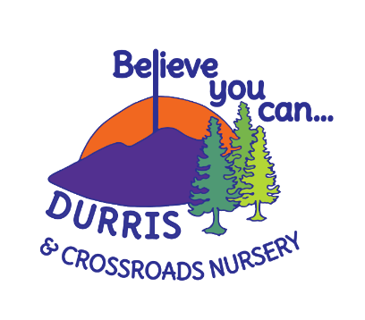
Crossroads Nursery Oral Health and Toothbrushing Policy

Crossroads Nursery promotes high levels of age-appropriate oral care and education linked to the importance of making good choices about what we should be eating and drinking. The following policy has been written based on:
- NHS Health Scotland, 2014
- Setting the table - Nutritional guidance and food standards for early years childcare providers in Scotland
- National Standards for Nursery and School Toothbrushing Programmes - Childsmile, May 2015
- Health and Social Care Standards My support, my life; Care Inspectorate, 2017.
  - 1.28 I am supported to make informed lifestyle choices affecting my health and wellbeing, and I am helped to use relevant screening and healthcare services.
- UNCRC – Article 24

The Early Years Lead Practitioner (EYLP) is the designated lead person who is responsible for the tooth brushing programme and ensures a benefit risk assessment is carried out prior to starting the programme.
- As part of the induction process the parent/carer is informed about the tooth brushing programme. It is the responsibility of the parent/carer to inform staff if the child has any requirements e.g. will use their own toothpaste.
- A record of this is maintained by the nursery in individual care plans and the key worker is aware of this
- If the parent/carer does not wish for their child to take part in the tooth brushing programme, they must contact Childsmile directly to arrange this.
- Toothbrushing is carried out at a designated time and place in the nursery with a member of the staff team.
- Toothbrushes are replaced once a term, or sooner if required (for example, when the bristles become splayed) this is the responsibility of the Early Years Practitioner (EYPs) who will maintain storage bus and toothbrushes. HPS, 2018, “Infection Prevention and Control in Day-care and Childminding Settings”
- Toothbrushes are individually identifiable for each child.
- Toothbrushes are stored in appropriate storage systems or individual ventilated holders.
- Storage systems which do not have covers are stored within a designated trolley or in a clean, dry cupboard.
- Storage systems, trolleys and storage areas are cleaned, rinsed and dried at least once a week (more if soiled) using warm water and detergent.
- Local monitoring of tooth brushing programmes by Childsmile staff occurs twice per school year.
- Monitoring includes observation of the tooth brushing session; discussion of the Standards with the EYLP; feedback to the local Childsmile Coordinator and arrangement of a follow-up visit.
- Staff will follow the tooth brushing guidelines set out by Childsmile.
- Childsmile information will be available to staff and will be located in the policy folder within the Nursery.
- Food and drink choices offered during snack will follow the guidelines set out by Setting the table. It will be the responsibility of the Early Years Senior and Lead Practitioner to ensure that new or temporary staff are familiar with this policy and that the policy is being implemented by all staff. This policy will be reviewed annually and changes made as appropriate.

