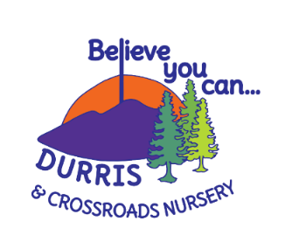
Crossroads Nursery Clean Air Policy

Article 24: The United Nation's Convention on the Rights of the Child (UNCRC)
Every child has the right to the best possible health. Governments must provide good quality health care, clean water, nutritious food, and a clean environment and education on health and well-being so that children can stay healthy
Crossroads Nursery adheres to Aberdeenshire Council Clean Air Policy. There are posters around the school building to ensure all visitors and users understand that there is no smoking on the premises, in the building or in the car park.
CO2 monitors are also used in the main play areas to ensure that the carbon dioxide levels are not at a dangerous level for children and staff.

