Useful Links for Home Learning
Literacy
Literacy and English – BBC Bitesize  This BBC website is full of lots of activities that supports your children’s learning. There are videos, games and reports that engage children of all ages | School Radio - School Radio (bbc.co.uk)  Learning resources offering video, audio and downloads covering music, dance, history, collective worship, literacy and maths. | cool-reads.co.uk - books for 10-15 year old readers by 10-15 year old reviewers  Online books for children to read
Class Clips - BBC Teach  Hundreds of short educational videos covering a variety of topics. | Oxford Owl for Home: help your child learn at home - Oxford Owl  Free ebooks all the time for children of primary age | 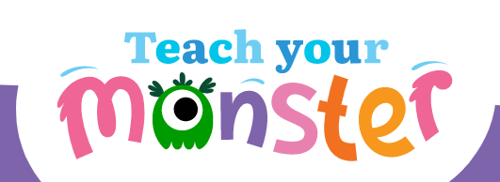  Teach Your Monster: Free Phonics, Reading and Mathematics Games  This is always free for the online version. A great game for early and first level.
Crickweb | KS2 Literacy  Online games to teach your child about spelling, sentences, verbs, collective nouns and much more. | ICDL - International Children's Digital Library (childrenslibrary.org)  An online library of books in different languages to read with children. | Spelling and Grammar, English Games for 7-11 Years - Topmarks  Spelling and grammar games
Pobble
An online writing platform with a daily picture with prompts for writing and discussion.

Numeracy
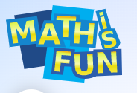  Math is Fun (mathsisfun.com)  A simple webize with exercises for additional homework. It has both printable worksheets and fun games to play. | Khan Academy | Free Online Courses, Lessons & Practice  Fantastic website that provides informational and instructional videos on various concepts – particularly maths. | Maths - BBC Bitesize  This BBC website is full of lots of activities that supports your children’s learning. There are videos, games and reports that engage children of all ages
Maths - Topmarks Search  Lots of free online games to practice concepts in maths. | 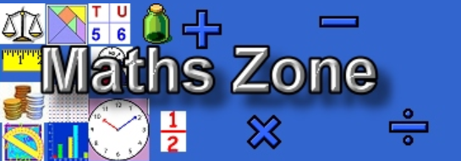  Woodlands Resources Maths Zone - Free Maths Games (primaryhomeworkhelp.co.uk)  This website covers it all

Other
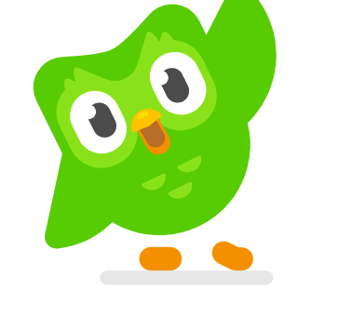  Duolingo - The world's best way to learn French  Duolingo – a free online resource where children can learn various languages. | Learning tools, flashcards, and textbook solutions | Quizlet  This is an app aimed at helping children revise for tests and increase their knowledge on a specific subject. Children can create study sets for concepts they need to review. | Welcome to Python.org  If you need help getting started there may be some videos on ‘You Tube’. Choose carefully before watching. A great way to develop logical thinking and learn a computer
Scratch - Imagine, Program, Share (mit.edu)  Scratch is a coding programme for children. | https://www.natgeokids.com/uk  Children can read about the world of animal and find facts out. A useful website to help develop children’s understanding of nonfiction texts. | https://www.activityvillage.co.uk/  Activities linked to different topics
Primary games - BBC Bitesize
Lots of online games to support various areas of the curriculum

