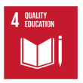
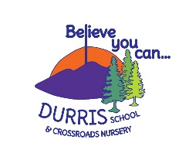
The Durris Deal
DURRIS PRIMARY/CROSSROADS NURSERY
VISION AND AIMS

Durris School is committed to being an excellent school community in which everyone is respected and valued, stimulated and supported in a caring environment, enabling all to achieve their very best.

At Durris School we have 3 main values – Kind Responsible Creative
What our children want  To learn how the world works e.g. science, history  How to use a wide range of technology safely and effectively  To be able to make friends and look after each other  Achieve things you didn’t think you could do!  We want to learn how to look after our environment for the future  To be confident with our literacy and numeracy skills  To learn the basics of another language  To be able to make good choices to stay fit and healthy | What parents want for their children  To develop and have confident literacy and numeracy skills  To be inspired, challenged and engaged  To develop good communication skills, friendships and the ability to socialise  To feel safe, nurtured and listened to  To have a rich variety of learning opportunities, including forest schools, trips and cluster events  To have an understanding of the world we all live in whilst developing tolerance  To be happy, confident and supported in their learning | What staff want for the children  To feel safe, secure, supported, included and nurtured  To reach their full potential, whilst being challenged appropriately  To have an understanding of the world around them and develop a curiosity for the wider environment  To have the opportunity to develop a wide variety of skills for learning and life as well as achieving academically  To be happy, kind, thoughtful and respectful  To be an active member of their community – locally and globally

