School Improvement Plan Update – I hope everyone who managed to attend our open morning in May enjoyed hearing about all our learning this term including The Global Goals, Fair Trade, Growth Mindset, The Learning Pit and seeing the children share their learning of British Sign Language.
P5-7 have also been to Crathes School to learn about Fairtrade cotton. The P5-7’s also attended an event to showcase their learning on the Global Goals in Aberdeen.

Forest Schools - At Forest Schools we have enjoyed working with Willow Lohr this term – improving our knife skills, fire safety and making musical instruments.

Staffing update – There will be significant staffing changes at Durris next session. Mrs Donaldson has decided to retire after a long teaching career. Mrs Grahamslaw has decided not increase her hours at Durris and will be moving to another school. Miss Cattell will complete her probation year with us and then move onto a fulltime post at a different, bigger school. I would like to take this opportunity to thank all of them for all of their hard work, professionalism and friendship during their time at Durris School.
We have a new full time appointment Mrs Lynsey Hannaford, who will be teaching in the P1-4 class next session. We also have a preferred candidate who will share teaching the P5-7 class with myself next year.
I am hoping that both new teachers will have the opportunity to meet the children prior to the end of this term.
School Show – This session our school show is called ‘The Pirates of the Curry Bean’. It is on Monday 25th June starting at 7pm in Kirkton Hall. Tickets cost £6.00 for adults and £3.00 for U16’s/Concessions. We look forward to seeing you there! Aaarghh!
Pupil Group Updates
Eco – Our Eco group organised a Waste Free Tuesday on 19 June. Children have been encouraged to take their snack and packed lunch in reusable containers to minimise the waste we create at Durris on that day. They will also soon be digging up the school tatties – we hope to make something yummy and tasty for everyone to try.
Community – The Community Group have been planning their Geocaches – and plan to hide one at school and two at Drum Castle Estate. Please have a go at finding them over the summer and logging your finds! We have also organised a ‘Crazy Hair Day’ on Wednesday 27 June. Pupils are asked to come to school with wacky hair and pay a donation to help raise funds to pay for Chantal, the little girl we sponsor from Burundi, to be able to go to school for the next year. This helps support Article 28: (Right to education): All children have the right to a primary education which we have been learning about.

Pupil Voice – The Pupil Voice group have revamped our Red Bander playground volunteer system. Children will now wear a high visibility jacket, only be on duty for one day at a time and be responsible for teaching and encouraging fun games for all to play. The group also designed a new rota for this involving P4-6 children.
School Car Park – we hope that this may be progressing shortly – watch this space for further updates! In the meantime, may I please remind parents to be mindful of their parking at the front of the school? Please be especially careful not to make exit/entry dangerous or tricky for our understanding neighbours – many thanks.
Summer Reading Challenge This year’s challenge starts on Thursday 28th June and runs until Saturday 25th August 2018. Youngsters often read less during the summer holidays. Our Summer Reading Challenge is a fun and accessible activity for children of all ages and aims to promote reading, encourage progression, support curricular outcomes and involve children in a cultural activity. Children receive a stamp or sticker for each book they read and will receive a book prize after reading six or more books, depending on their age group. As well as the reading challenge, our libraries also run a creative competition. Get down to your local library and find out more when the challenge commences at the end of June.
Parents’ Committee - A huge thank you to the Parents’ Committee for organising the hugely successful BBQ last Friday evening. It was very well attended and a good time was had by all.
End of Term – Our end of term service will be on Friday 6th July, 2.30pm at Durris Church
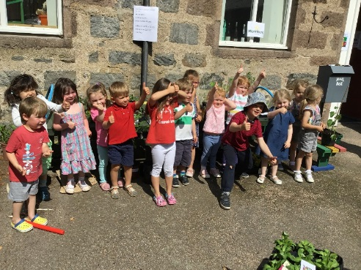
Nursery News - Mrs Duncan and Mrs Everest would like to pass on a huge thank you to everyone involved in the Plant Sale at the beginning of the month. We raised a total of £600.27! Amazing result.
As the year comes to an end, we would also like to sincerely pass on another huge thank you to all those family members who have helped out as volunteers and in many other ways throughout the year.
Good luck to Daniel, Jessica, Lucia and Lucy, our Squirrels, who will be leaving us to join Durris School soon. We will miss you all and know you will do really well.
Finally we look forward to welcoming our new hedgehogs in August, and can’t wait to meet you all at our new starters meeting next Tuesday from 9.30-10.30.

School Dates
Wed 20th June – Fri 22nd June - P7 Link Days @ Academy
Monday 25th June - Show @ Kirkton Hall
Tuesday 26 June - Nursery open morning for new starts @ 9.30am
Monday 2nd July - P6 & 7 First Aid @ Drumoak School
Wednesday 4th July - Forest Schools
Friday 6th July - Last Day of Term, Durris Church @ 2.30pm
Tuesday 21st August - Term Begins

