School Improvement Plan Update – We have continued to learn about the Global Goals as a whole school and the UNICEF Rights of the Child this term.

Staffing update – Mrs Sinclair will be leaving us at the end of term. We are very sad to see her go but she is moving to the Academy as part of her own professional development. I would like to wish her all the best and say a huge thanks for all of her hard work over the last two years. I will be interviewing on Thursday to fill the PSA hours until summer.
Mrs Jenny Wood has been successfully appointed as our new Support for Learning teacher – I would like to welcome her to working with the Durris Community.
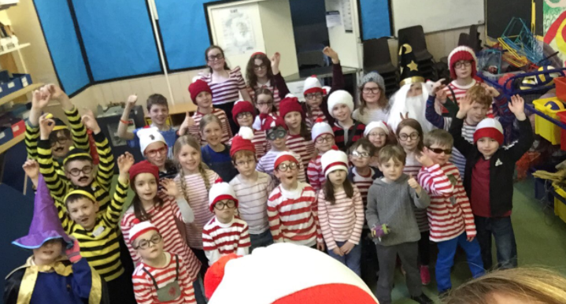
World Book Day – we had to delay our celebrations this year due to the snow but all had a fantastic day on Thursday 15th March. We used technology to help us with our Where’s Wally hunt and also had many fantastic potatoes decorated as favourite book characters.

Parents’ Committee – many thanks to the Parents’ Committee who hosted a Mothers’ Day afternoon tea earlier in the month, a fantastic £350 was raised.
Save the Date! We are having an open morning on Thursday 10th May, starting at 9.15am. This will be an opportunity for pupils to share lots of our learning from this session, including Global Goals, Growth Mindset and Fairtrade to name a few. Invitations will be sent out next term. There will be the opportunity to have a Fairtrade cuppie and as part of our work on Global Goals we are inviting you to bring your own mug – eliminating any paper/plastic waste! Please download a QR reader to your phone to help you engage with the learning tour we are planning, many thanks.
School Lunches - The price of a two course standard meal in all Primary Schools will increase by 10p from W/C 16th April, the cost will now be £2.30.

Parent Council Essentials - Hill of Banchory Primary School, Monday 23 April 2018 6.30-8.30pm. Refreshments from 6.15pm

Have a fantastic Easter Holiday!
Nursery News
Many thanks to Mrs Wilson for coming to play the piano for National Sing Up Day – we all had a lovely time!
Easter Egg hunt and bonnet parade will be this Thursday 29th March. We are really looking forward to seeing all of your beautiful creations.

School Dates for Term 4

Monday 16th April - Term Begins
Wednesday 25th April - Forest Schools
Wednesday 2nd May - P7 Science & Technology Day @ Academy
Monday 7th May - Holiday
Tuesday 8th May - Parent Council Meeting
Wednesday 9th May - Forest Schools
Friday 11th May - P2 Sport Morning @ Drumoak School
Tue 15th – Fri 18th May - P6/7 Residential Trip @ Glenshee
Wednesday 23rd May - Forest Schools
Thursday 24th May - P7 Visit to Academy
Friday 25th May - P3-7 Potted Sports @ Crathes School
Monday 28th May - Sports Day @ Knockburn Loch
Monday 4th June - Holiday
Tuesday 5th June - Learning Conversations
Wednesday 6th June - Forest Schools
Monday 11th June - Burnett Cup 6pm @ Crathes School
Tuesday 12th June - P7 Try a Sport Day
Wednesday 20th June - Forest Schools
Wed 20th June – Fri 22nd June - P7 Link Days @ Academy
Monday 25th June - School Performance @ Kirkton Hall
Wednesday 4th July - Forest Schools
Friday 6th July - Last Day of Term, Durris Church @ 2.30pm
Tuesday 21st August - Term Begins

