School Improvement Plan Update – We had two successful days last week where we focussed on Forest Schools and Global Goals, increasing staff knowledge in both these areas will improve and enrich the experiences we are able to offer the pupils.

Staffing update - Mrs McNay has reduced her working hours and will no longer be teaching at Durris, she has been a Support for Learning teacher here for over 12 years and I would like to thank her for all her hard work. Mrs Wood will be covering SfL until a permanent member of staff is appointed. Mrs Jones will be finishing with us on Friday 23 February, the post of PSA will be re-advertised shortly. Miss McCulloch, our Intervention Prevention Teacher has also finished working in Banchory cluster, to take a post nearer home, this post too will be advertised.

School Website - Many thanks to all parents who completed the online survey regarding our website. I will be working with the Parent Council to improve it so relevant and up to date information which parents have requested will be available.

World Book Day - World Book Day is on Thursday 1 March 2018. We will be celebrating the day with lots of literacy activities and opportunities to read. We will also have a fancy dress theme for the day – ‘Where’s Wally?’ for all pupils and staff. So feel free to come to school as Wally, Wenda, Odlaw, Wizard Whitebeard or even Woof! The whole school will be taking part in a homework challenge to decorate a potato as a favourite book character.

Resources - We have recently purchased a large number of new reading books for the P1-4 class and also some new novel collections for the senior class. We have also been successful in a bid for more resources to help our delivery of Forest Schools – including another fire bowl, Kelly kettle and several more saws. The Parents’ Committee have also kindly purchased a new rug for each class and some cushions to help make our reading areas more comfortable and appealing.
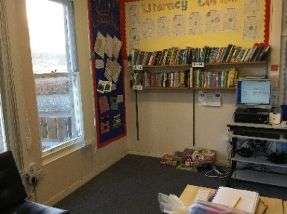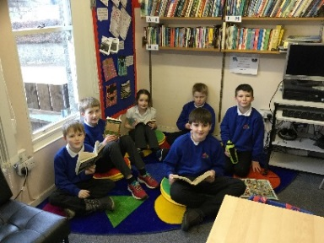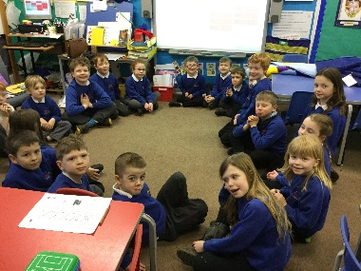
Before After! Before After!

Clubs - Our clubs have been popular with pupils - Sewing, Yoga, Cross Country, Lego and Puzzle & Challenge are now all up and running. These clubs offer pupils a chance to learn a variety of skills and experience something new.

Rag Bag – Thank you to everyone who donated, we collected 217kg and raised £86.80 for school funds.

SPTC - For Banchory/Alford/Aboyne Clusters
Monday 5th March ‘Parent Council Essentials’ 6:30–8.30pm in Hill of Banchory Staff Room.
Monday 14th May ‘How to Improve Your School’ 6:30pm Hill of Banchory Staff Room.

Parents’ Committee – Please Save The Date for our Mother's Day Afternoon Tea (all Mums, Grannies, Aunties, neighbours and friends from near and far are welcome). Sunday 11th March, it promises to be a really lovely afternoon, with bubbles, cake and great company. Details to follow.

Nursery News

Nursery have been up to lots of exciting things recently especially working with parents who have kindly volunteered their time to come in and work with us.
A really big thank you to Freddy’s mum Morag who came in and worked with us designing a pallet garden which we have entered into Design a One Planet Picnic Pocket Garden 2018 competition. Another huge thank you to Isabel’s mummy Yi-Pei for sharing her cultural heritage with us celebrating Chinese New Year making some fantastic fire crackers, lanterns and teaching us to count to ten in Mandarin.

- Friday 23rd February -Nursery Parents’ Coffee Morning: Join other parents and carers in the Big Room from 9am to talk about what you would like to feature in nursery for the spring and summer term. Refreshments provided.
- Thursday 1st March - World Book Day. Celebrating books, songs and rhymes from other countries, including parents joining us to use their home language – Polish; Mandarin; French; Doric; Welsh; Zulu and Sign Language!
- Friday 9th March - “Feasty Friday” Mother’s Day Celebration. Join us for Friday homemade snack to celebrate Mother’s Day.
- Wednesday 14th March - Sing Up Day. Using song as a powerful learning tool and to keep us healthy and happy! We will learn a bank of nursery rhymes and receive a certificate to celebrate.
- Thursday 22nd March - World Water Day is about focusing attention on the importance of water. The theme for World Water Day 2018 is ‘Nature for Water’ – exploring nature-based solutions to the water challenges we face in the 21st century. As part of our work toward our Green Flag Award we will be working with Freddy’s mum to look at how we can make a difference.
- Thursday 29th March - Forest Easter Egg Hunt and Easter Bonnet Parade.

School Dates for Term 3

Friday 23rd February - P6/7 ASC @ Banchory Academy
Monday 26th February - P6/7 Enterprise Day @ Drumoak School
Thursday 1st March - P5-7 Fairtrade Workshop @ Crathes School
Wednesday 7th March - Forest Schools
Thursday 8th March - P5-7 Absafe Visit
Wednesday 21st March - Forest Schools
Thursday 29th March - Last day of Term
Monday 16th April - Term Begins

