What a busy first term we have had at Durris and Crossroads. We will now be sending a joint newsletter – if you have any comments or feedback on any issues raised, please do not hesitate to contact us.

School Improvement Plan - this session we have several areas of development.

Reporting - We will be continuing to improve and refine our new reporting process. Our new reporting calendar can be found on the school website. Our Learning Journeys are part of our reporting to parents – they have been very well received. Can I please ask that they are signed and returned ASAP so we can ensure they are all ready to go out again the following fortnight? Many thanks.

Forest Schools – we will be continuing to embed our new skills in Woodlands Forest on a regular basis, ensuring we make best use of our fantastic local environment.

Learning and Teaching – We will be engaging with current research on how best to support pupils with a variety of needs.

Rights Respecting Schools Award – we will be undertaking an audit to help us work towards our Level 1 Award. We frequently refer to children’s rights in assembly to begin to raise awareness.
Visible Learning – we will continue to look at how children learn best, including Growth Mind Set and how to improve resilience.

Staffing update
Mrs Ashley Proctor has recently started working in the Westhill Cluster and has decided to make this move permanent. Mrs Proctor has been at Durris School for 14 years. I would like to take this opportunity to thank her for all of her hard work over the years.

Mrs Jane Kerridge had cut down to 1 day a week this session but has made the decision to fully retire at the October holidays. Mrs Kerridge has worked at Durris School for many years, in a variety of roles. I would like to take this opportunity to say thank you and wish her well in what I am sure will be a very active retirement!

Chickens
Our girls have finally arrived! A weekend rota has been issued, this has been drawn up by the Community Group. If you require to swap your allocated weekend please contact another family and organise the change. There is an information sheet with details of requirements and any eggs laid are yours to enjoy. We are currently in the process naming them – we will keep you updated. We will also need volunteers to look in on the girls during holidays – an email has been sent out this week.

Master Classes
We are running several Master Classes this term on Tuesday afternoons, these include – Wool Club, Cooking, Science & Maths challenges and a Craft group. Children choose their group and gain a variety of new skills and knowledge during these classes.

Forest Schools
We have started our regular sessions at Woodlands Forest on a Thursday morning. The children have thoroughly enjoyed the sessions so far – this week we will be cooking soup and making bread dampers. Many thanks to all our parent volunteers – we could not run these sessions without you. Next term the sessions will continue, but move to a Wednesday – a letter will be out shortly with dates and asking for volunteers.

Nursery News

ECO Committee
We are lucky to have some amazingly enthusiastic parents to help push forward our work as an ECO school focused on sustainability and working with our precious environment, teaching our very youngest students the value of protecting our natural assets.
After our inaugural meeting of the ECO committee 2017-18, we have some amazing projects lined up for this year which enhance and build on the solid base of knowledge and involvement which the nursery has built upon over the years. E.g. Willow weaving; paper making.

Parents coffee morning
At Crossroads we love working in partnership with parents, and realise what enormous benefits can be gained for all of us by sharing the wealth of expertise and experience that our families can offer, in order to enhance our children’s learning experiences.
Our parents arranged a coffee morning to discuss how we could improve our working together as a team and we are working with them to ensure how our communication in particular can be excellent. Consultation with parents is key to our success and we would like to thank all our mums, dads and extended family for all their contributions.

Welcoming new friends
Nursery have been concentrating on welcoming the new Hedgehog children who started this term. Our older Squirrels have been showing them the ropes and helping the little ones to learn about their environment and our routines and rules. We have seen some super helping with older children helping with putting on shoes, showing how we wash our hands, and especially at tidy up time.
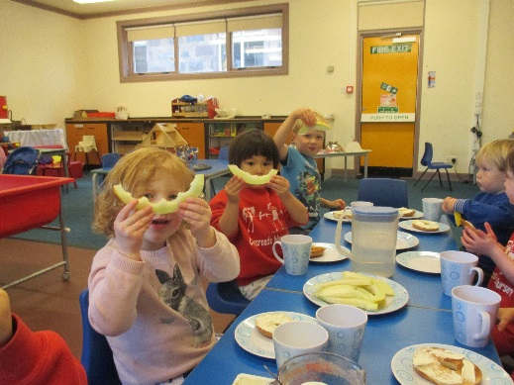
We have been enjoying making our own snacks especially “Feasty Friday” when we cook something special and all eat together. So far we have made apple and blackberry crumble, pizza, spaghetti carbonara and tarte tatin. The children have decided to “do a restaurant” for the parents one Friday very soon!

Forest school
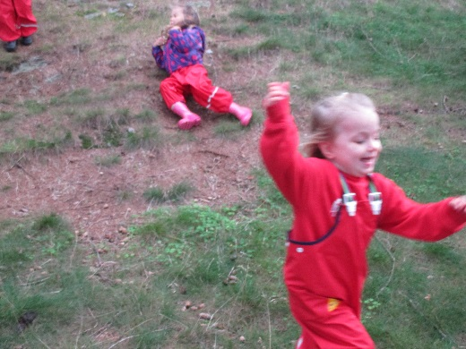We have all really enjoyed our Wednesday Forest School learning about nature and how we need to behave in the forest in order to remain safe and have fun whilst exploring our environment and thinking about the risks and benefits we gain from playing in the outdoors. The children have made their own risk assessments and talked in great detail about things they saw as challenges and how they could best approach them.
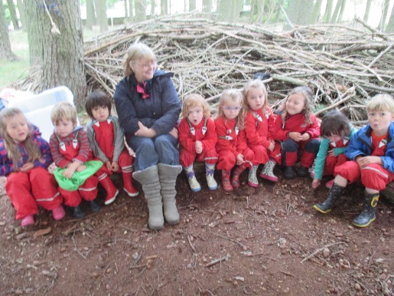
Learning Journals
The main way in which nursery communicate with parents and carers about their children’s progress is through our electronic Learning Journals. Nursery staff have created an online account for each child which parents can access through their email account. Observations of your child’s play and learning are regularly updated by Mrs Duncan and Mrs Everest and added to their learning Journal.
If you have any questions about how to access your child’s account please ask a member of nursery staff.

Dates for Term 2
Friday 13th October - Last Day of Term
Monday 30th October - Term Begins
Monday 6th November - Panto at Drumoak
Wed 8th – Fri 10th November - Bookfair
Thursday 9th November - Flu Vaccines
Mon 13th & Tues 14th November - In-Service Days
Wednesday 15th November - Learning Conversations
Monday 20th November - P3 Library Visit
Friday 24th November - P1 & P4 K’Next @ Drumoak Primary
Friday 1st December - P6/7 Ceilidh @ Drumoak School
Thursday 21st December - Christmas Party @ Kirkton Hall
Friday 22nd December - Church Service @ Durris Church
Last Day of Term
Monday 8th January - Term Begins

